ECA5604-5G/6G COMMUNICATION SYSTEMS
NAME: RAKESH KUMAR
REG NO:192412048
Ex.No.4: OFDMA Resource Block Allocation
Objective1:
Program:
clc; clear; close all;
% System parameters
bandwidth = 10e6; % 10 MHz
rb_size = 180e3; % 180 kHz per RB
% Total Resource Blocks
total_RB = floor(bandwidth / rb_size);
% Users
users = 1:6;
% RB allocation (simple equal + remainder distribution)
base = floor(total_RB / length(users));
…xlabel('User Index')
ylabel('Number of Resource Blocks')
grid on
% -------- Graph 2: RB Utilization --------
subplot(2,1,2)
plot(users, utilization, '-o', 'LineWidth', 2)
title('OFDMA Resource Block Utilization (%)')
xlabel('User Index')
ylabel('Utilization (%)')
grid on

Output:
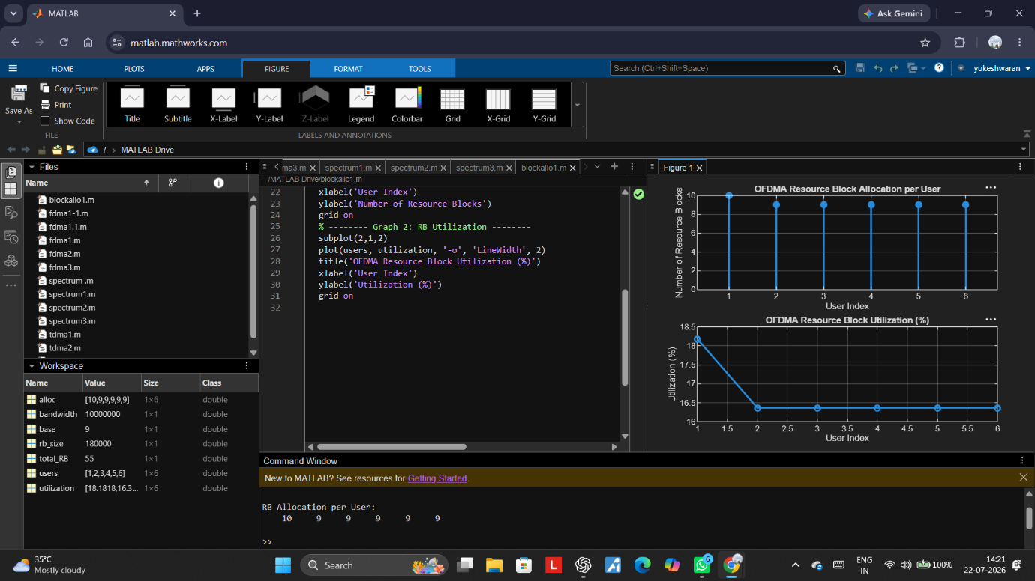

Objective2:
Program:
clc; clear; close all;
% Total system resource blocks
total_RB = 50;
% Number of active users
users = 1:5;
% RB allocation to users (example scenario)
alloc = [12 10 9 8 11];
% Resource Block Utilization (%)
util = (alloc / total_RB) * 100;
disp('Resource Block Utilization (%) per User:')
…xlabel('User Index')
ylabel('Number of Resource Blocks')
grid on
% -------- Graph 2: Utilization (%) --------
subplot(2,1,2)
plot(users, util, '-s', 'LineWidth', 2)
title('OFDMA Resource Block Utilization (%)')
xlabel('User Index')
ylabel('Utilization (%)')
grid on

Output:
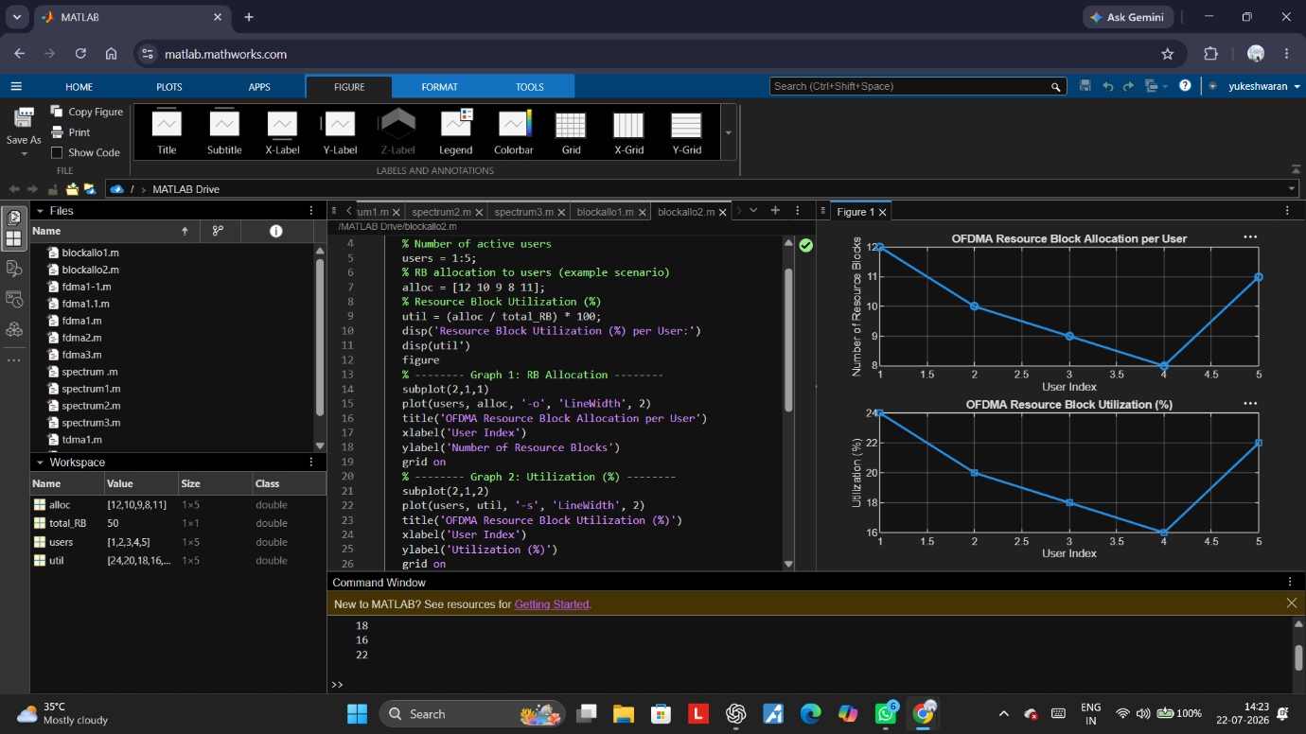

Objective3:
Program:
clc; clear; close all;
% System parameters
rb_bw = 180e3; % Bandwidth per RB (180 kHz)
users = 1:5;
% Allocated Resource Blocks per user
alloc_RB = [12 10 9 8 11];
% Modulation efficiency (bits/symbol)
mod_eff = [2 4 6 4 2]; % QPSK, 16QAM, 64QAM etc.
% Throughput calculation (Mbps)
throughput = (alloc_RB .* rb_bw .* mod_eff) / 1e6;
…xlabel('User Index')
ylabel('Throughput (Mbps)')
grid on
% -------- Graph 2: RB vs Throughput --------
subplot(2,1,2)
plot(alloc_RB, throughput, '-s', 'LineWidth', 2)
title('Resource Blocks vs Throughput Relationship')
xlabel('Allocated Resource Blocks')
ylabel('Throughput (Mbps)')
grid on
